- Stacks and Queues
Stack.java
public class Stack<T extends Object>{
private int capacity;
private T[] arr;
private int top;
public Stack(int capacity)
{
this.capacity = capacity;
this.arr = (T[]) new Object[capacity];
this.top = -1;
}
public void push(T element)
{
if(this.isFull())
System.out.println("ERROR: Stack Overflow!");
else
{
this.arr[++top] = element;
}
}
public T pop()
{
if(this.isEmpty())
{
System.out.println("ERROR: Stack Underflow!");
return null;
}
else
{
T element = this.arr[top];
this.arr[top] = null;
top--;
return element;
}
}
public boolean isEmpty()
{
return (this.top == -1);
}
public boolean isFull()
{
return (this.top == capacity - 1);
}
public T peek()
{
return this.arr[top];
}
public int size(){ return this.capacity; }
}

Problem1.java (Driver class)
public class Problem1 {
public static boolean checkBalanced(String s)
{
// first, create either a stack or a queue (here, a Stack has been used)
Stack<Character> stack = new Stack(s.length());
/*
Then: For each character, either:
if the character is an opener, add it to the Stack
if the character is a closer, pop it from the Stack
and check for a matching pair
*/
for(int i = 0; i < s.length(); i++)
{
// if the ith character is an opener, it should be pushed to the Stack
if(s.charAt(i) == '{' || s.charAt(i) == '(' || s.charAt(i) == '[')
stack.push(s.charAt(i));
// if the ith character is a closer, it should be poped out of the Stack
// and should be checked if the pair is a matching pair
if (s.charAt(i) == '}' || s.charAt(i) == ')' || s.charAt(i) == ']')
{
// if it is a closer and there is no matching pair of it, return false;
if(stack.isEmpty())
{
return false;
}
// now we need to pop the top character from the Stack
// if it does not form a pair with the ith character, return false
else if(!match(stack.pop(), s.charAt(i)))
{
return false;
}
}
}
/*
Once all the characters have been processed:
return true if all conditions are satisfied
else, return false
*/
if(stack.isEmpty())
return true;
else
return false;
}
public static boolean match(char opener, char closer)
{
return(opener == '(' && closer == ')' ||
opener == '{' && closer == '}' ||
opener == '[' && closer == ']');
}
public static void test(String s, boolean expected)
{
boolean result = checkBalanced(s);
String message = (result == expected ? "Test succeeded!" : "Test failed: ") + s;
System.out.println(message);
}
public static void main(String[] args) {
String balanced = "[()] {}{[()()]()}";
String unbalanced = "[(])";
test("[]", true);
test("[()]", true);
test(balanced, true);
test(unbalanced, false);
test("(", false);
}
}

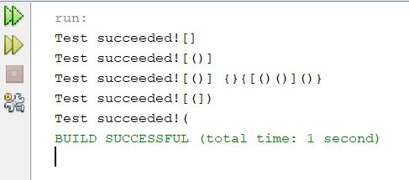

- Analysis and Algorithms
a)

Formula for tilde notation;
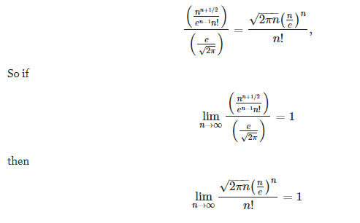

Therefore, through simplification, the running time of Problem2.java is 1 minutes and 12 seconds. The running time satisfies the correlation between T(n)∼cf(n) where f(n) a function and c is a constant.
b)

Memory consumption in java applications is implementation-independent. Therefore primitive data types, objects, arrays and strings all have different ways determine their memory usage.
The memory consumption of the algorithm is 10n²

3. Mergesort
private Merge() { }
// stably merge a[lo .. mid] with a[mid+1 ..hi] using aux[lo .. hi]
private static void merge(Comparable[] a, Comparable[] aux, int lo, int mid, int hi) {
// precondition: a[lo .. mid] and a[mid+1 .. hi] are sorted subarrays
assert isSorted(a, lo, mid);
assert isSorted(a, mid+1, hi);
// copy to aux[]
for (int k = lo; k <= hi; k++) {
aux[k] = a[k];
}
// merge back to a[]
int i = lo, j = mid+1;
for (int k = lo; k <= hi; k++) {
if (i > mid) a[k] = aux[j++];
else if (j > hi) a[k] = aux[i++];
else if (less(aux[j], aux[i])) a[k] = aux[j++];
else a[k] = aux[i++];
}
// postcondition: a[lo .. hi] is sorted
assert isSorted(a, lo, hi);
}
// mergesort a[lo..hi] using auxiliary array aux[lo..hi]
private static void sort(Comparable[] a, Comparable[] aux, int lo, int hi) {
if (hi <= lo) return;
int mid = lo + (hi - lo) / 2;
sort(a, aux, lo, mid);
sort(a, aux, mid + 1, hi);
merge(a, aux, lo, mid, hi);
}
//Rearranges the array in ascending order, using the natural order.
public static void sort(Comparable[] a) {
Comparable[] aux = new Comparable[a.length];
sort(a, aux, 0, a.length-1);
assert isSorted(a);
}
//Helper sorting function.
// is v < w ?
private static boolean less(Comparable v, Comparable w) {
return v.compareTo(w) < 0;
}
// Check if array is sorted - useful for debugging.
private static boolean isSorted(Comparable[] a) {
return isSorted(a, 0, a.length - 1);
}
private static boolean isSorted(Comparable[] a, int lo, int hi) {
for (int i = lo + 1; i <= hi; i++)
if (less(a[i], a[i-1])) return false;
return true;
}
// Index mergesort.
// stably merge a[lo .. mid] with a[mid+1 .. hi] using aux[lo .. hi]
private static void merge(Comparable[] a, int[] index, int[] aux, int lo, int mid, int hi) {
// copy to aux[]
for (int k = lo; k <= hi; k++) {
aux[k] = index[k];
}
// merge back to a[]
int i = lo, j = mid+1;
for (int k = lo; k <= hi; k++) {
if (i > mid) index[k] = aux[j++];
else if (j > hi) index[k] = aux[i++];
else if (less(a[aux[j]], a[aux[i]])) index[k] = aux[j++];
else index[k] = aux[i++];
}
}
/**
* Returns a permutation that gives the elements in the array in ascending order.
* @param a the array
* @return a permutation {@code p[]} such that {@code a[p[0]]}, {@code a[p[1]]},
* ..., {@code a[p[N-1]]} are in ascending order
*/
public static int[] indexSort(Comparable[] a) {
int n = a.length;
int[] index = new int[n];
for (int i = 0; i < n; i++)
index[i] = i;
int[] aux = new int[n];
sort(a, index, aux, 0, n-1);
return index;
}
// mergesort a[lo..hi] using auxiliary array aux[lo..hi]
private static void sort(Comparable[] a, int[] index, int[] aux, int lo, int hi) {
if (hi <= lo) return;
int mid = lo + (hi - lo) / 2;
sort(a, index, aux, lo, mid);
sort(a, index, aux, mid + 1, hi);
merge(a, index, aux, lo, mid, hi);
}
// print array to standard output
private static void show(Comparable[] a) {
for (int i = 0; i < a.length; i++) {
StdOut.println(a[i]);
}
}
/**
* Reads in a sequence of strings from standard input; mergesorts them;
* and prints them to standard output in ascending order.
*
* @param args the command-line arguments
*/
public static void main(String[] args) {
String[] a = StdIn.readAllStrings();
Merge.sort(a);
show(a);
}
}

4. Queues and Linked Lists
a)
Here for enqueue we have to consider whether the queue is empty or not. If the queue is empty, that is the last node is null. So, here simply we point the last to the newLast node. Since we are using circular queue point the last.next to itself,
last.next=last.
If the queue is not empty then there will be at least 1 node in the queue. Here we have to point
- The newLast.next to the head node of the queue(which is last.next)
- last.next to the newLast node
- And move the last node to newLast as newLast node will be the current last node of the queue.
And finally increase the count of N.
For dequeue,
- If queue is empty then throw exception(given already)
- if queue contains only one element, then get the item value and make the last node to null as we will remove the element.

- if queue contains more than one, then we know that last.next points to the head node of the queue as in circular linked list the last node points to the 1st node get the head node.
- Now the next head node will be the node next to the current head.So, point the last.next to head.next
- Lastly, decrease the value of N and return the item value.
CODE
class Queue{
private Node last;
private int N;
private class Node{
Item item;
Node next;
}
public boolean isEmpty(){return last==null;}
public int size(){return N;}
public void enqueue(Item item){
Node newLast = new Node();
newLast.item=item;
if(isEmpty()){
last=newLast;
last.next=last;
}
else{
newLast.next=last.next;
last.next=newLast;
last=newLast;
}
++N;
}
public Item dequeue() throws Exception{
if(isEmpty()){
throw new Exception("dequeue of empty queue");
}
Item value;
if(N==1){
value=last.item;
last=null;
}else{
Node root=last.next;
last.next=root.next;
value=last.item;
}
--N;
return value;
}
}

b)
For the input to be or not to - be - - that - - - to the output is:
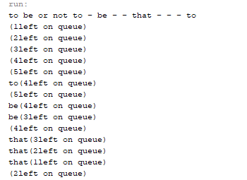

The structure of the images will be similar to that are shown above. The only difference is that the last node will not point to null but to the starting (head) node of the queue.
Below is the structure of it:

